Printed Name: _______________________________________________ M / F Birth Date ____/_____/_____
Applicant’s Signature: ____________________________________________________________________________
Authorized Proxy’s Signature: ______________________________________________________________________
Address _____________________________________________________ City ____________________________
Zip ________________ Phone _(__________)___________________________________________________
County: BLOUNT KNOX LOUDON MONROE SEVIER _

Veteran in Household Disabled on Household

Number of People in Household: Children (age 0-17) ______ Adults age (18-59) ______ Seniors (age 60+) ______

Other people Living in your Household:

2 Name ________________________________ Relationship ________________ M / F Birth Date ___/_____/_____
3 Name ________________________________ Relationship ________________ M / F Birth Date ___/_____/_____
4 Name ________________________________ Relationship ________________ M / F Birth Date____/_____/_____
5 Name ________________________________ Relationship ________________ M / F Birth Date ___/_____/_____
6 Name ________________________________ Relationship ________________ M / F Birth Date ___/_____/_____
7 Name ________________________________ Relationship ________________ M / F Birth Date ___/_____/_____
Is your household income AT OR BELOW the limits listed below for the total number of people living in your household? Is so, you are eligible to receive USDA Foods in TEFAP.
Yes or No (Circle one as is applicable)
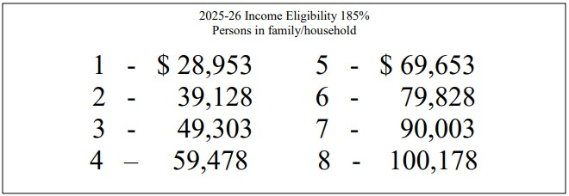
You are also eligible to receive USDA Foods in TEFAP if your household participates in any of the following programs. If you or anyone in your household participates in any of these programs, please check all applicable boxes:

SNAP
Families First
Supplemental Security Income (this is NOT Social Security income)
Low Income Home Energy Assistance Program
Residence in Public Housing
Meets USDA Income Level

I hereby acknowledge having been given the notice of nondiscrimination and
Attachment A: Written Notice of Beneficiary Rights for TEFAP as part of this Intake Form.

